It gets messy to manage multiple module dependencies. One thing we can do to make it easier is to manage the version of the dependencies in the root pom file.

So, instead of defining the version in the dependencies, we can define them in the property and put the property variable in the dependency version. In the child modules, we can just define the artifact and group id of the dependency, it will automatically get the version number from the parent.

In this way it will be easier to change/update the versions for while project without breaking it.

Example,

* For the pom/parent pom file,

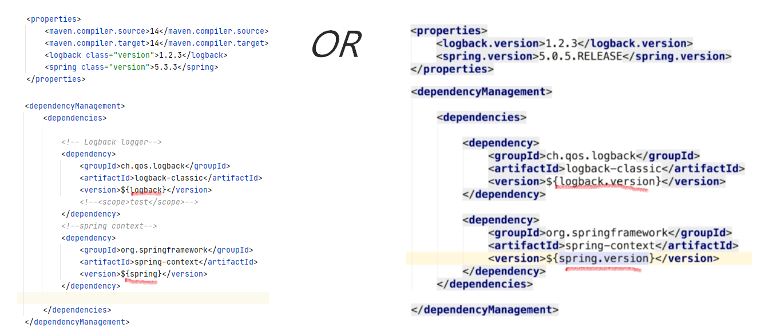

* For the child module pom file, 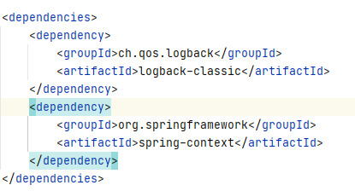

**In case of child needs dependency on another child module**

Here we have to specify it in the child pom.xml file.

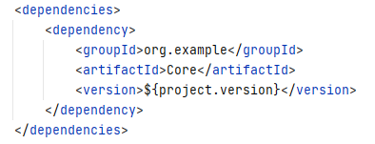

For example, here we add the Core module dependency, in this case we do need to specify version. Because the pom.xml file will only auto import versions from parent dependency. This case both of them are child.

For version number, we used a project.version which is exposed to us by maven.